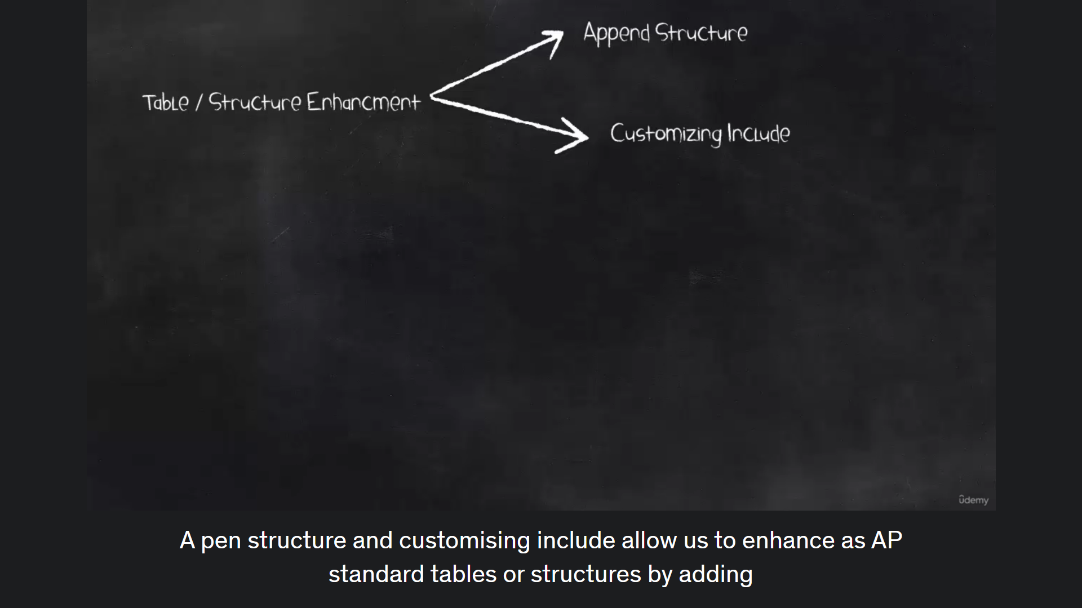

Append structure and customising include allow us to enhance as AP standard tables or structures by adding fields to them, but not part of as a standard object or SFP object.

What are the differences between Appends Strattera and customising include?

Almost all escapee's standard tables or structures can be enhanced by using a pen structure to create.

To create a append structure, we create append structure as customer object. The field names in an append structure must be in customer namespace.

It must begin with wither YY or Zz.

This prevents naming conflicts with the SFP standard fields.

And then we attach the append structure to a standard table or a structure definition, whenever the asset based under table or structure is activated.

The system services for all active appends, structures for that table and attaches them to the database

One append structure can be assigned to single table.

One table may have several append structure

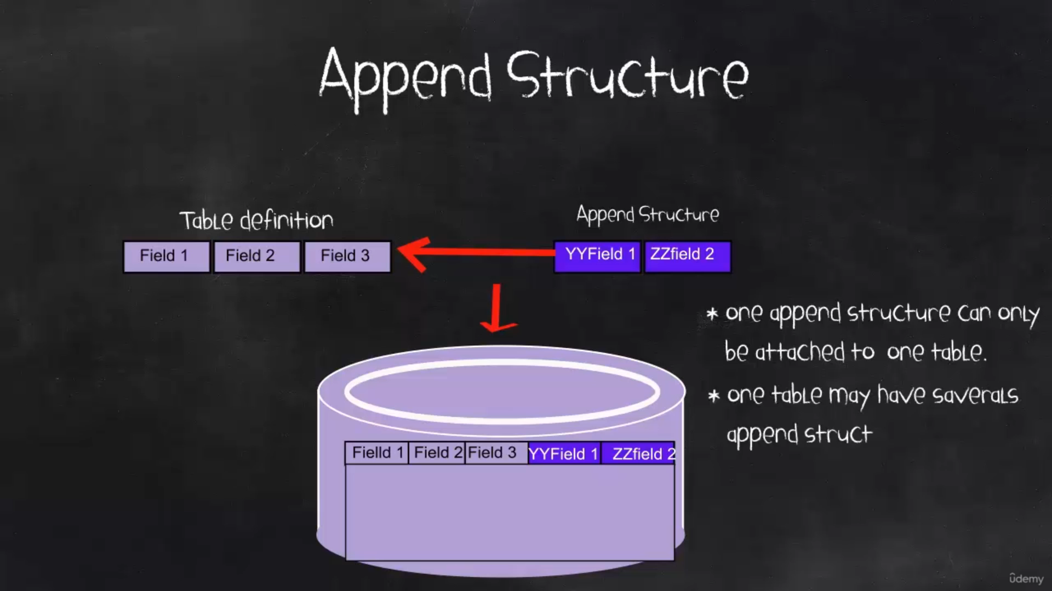

customising include

not all standard tables or structures can be enhanced by using customising include only the tables or structures that have customising include statement inside it.

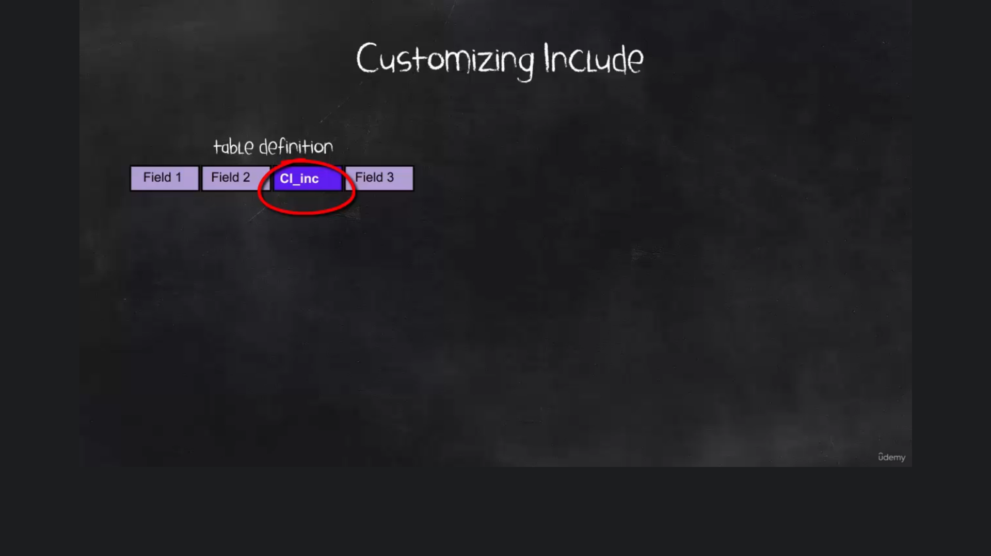

If we want to implement the customising include, then we double click. On customizing include statement

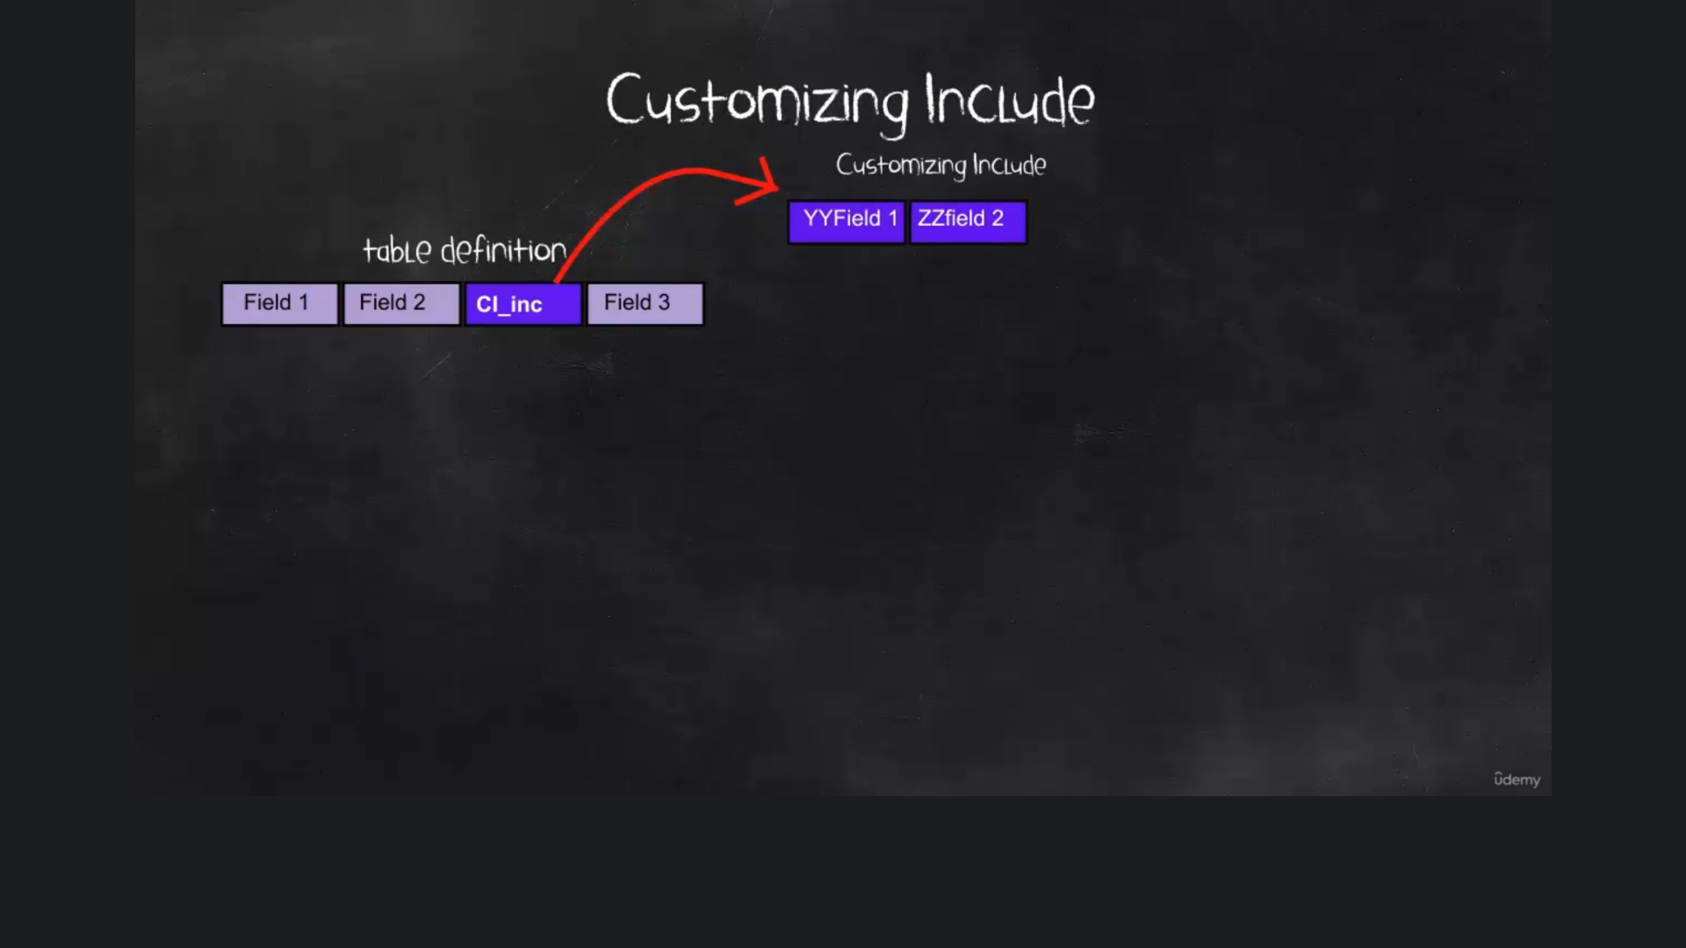

The customising include field names must lie in the customer namespace. That's like field names in appends structures.

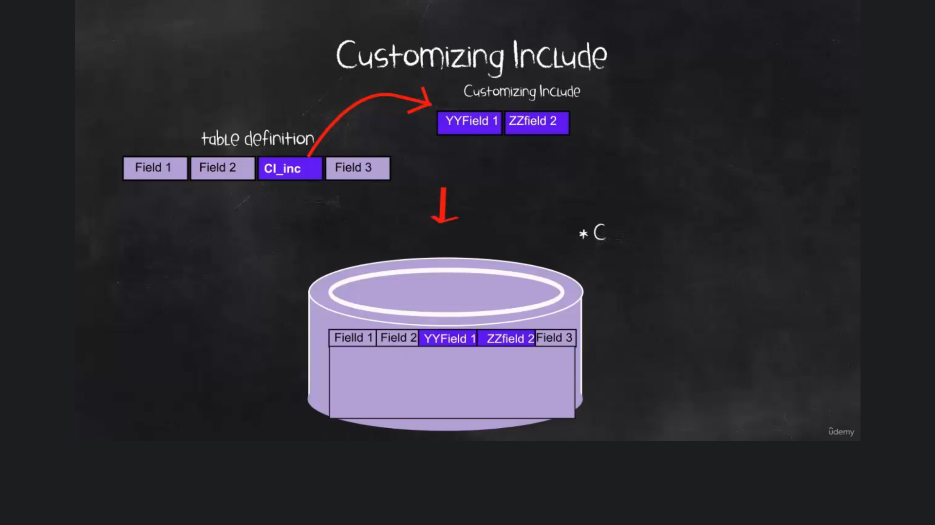

Customizing include is pre planned by sap.

One customizing include can be inserted to more than one table.

